英语语法整理
1、词类
  - 动词词组：几乎每年必考。
  - 形容词和副词：比较级和最高级。
  - It作形式主语及形式宾语：常考，it本身无意义。
2、动词的时态和语态
  - 学会抓时间状语。
  - 重点关注：进行时、完成时和完成进行时，客观真理要用一般现在时。
  - 固定句式：如Hardly…when…等。
  - 主动表被动。
3、非谓语动词
  - 牢记哪些动词后的宾语只能是不定式(to do)、动名词(doing)，哪些二者兼可。
  - 作定语、状语、补语。
  - 注意：现在分词与过去分词的区别，即主动与被动这个最重要的区别。
4、虚拟语气
  - 记住与现在，过去，将来相反的三种情况。最常考：与过去相反的情况。
  - wish，as if 后接三种情况：常考。
  - 常考：suggest，demand，require，order等表示建议、要求、命令的词后面加从句时，从句里谓语要用(should)+动词原形，如果是被动则用should +be +动词过去分词。
5、情态动词
  - must be表对现在事情的肯定推测。
  - can’t be表对现在事实的否定推测。
  - must have + v-ed表示对过去事实的肯定推测。
  - can’t have + v-ed表示对过去事情的否定推测。
  - should have + v-ed则表示过去应该做某事而没有做。
6、定语从句和名词性从句
  - 定语从句：必考。注意点：关系代词和关系副词的区别，as和which的区别，限制性和非限制性定语。
  - 从句的区别：定语从句和同位语从句的区别。注意名词性从句引导词的选择和语序。
7、状语从句
  - 重点关注：in case, unless等连词引导的条件状语从句。注意：while, when, until, not…until, before, since引导的时间状语从句。
  - 同时关注：目的和结果状语从句。
8、特殊句式
  - 倒装句：必考，重点关注部分倒装句，as在倒装结构中的用法及意义等，都是考生应当重视的地方。
  - 强调句：必考。
  - 反意疑问句：不能忽视，判定方法：前肯定后否定or前否定后肯定，疑问部分主语应与从句主语一致。e.g. I believe she knows it, __________? （doesn’t she）
  - Let‘s ，shall we？ Let us ，will you？
9、主谓一致题
往往出题者都是考谓语动词选单数这种情况。
  - 就近原则题：注意。
  - 关注：主语中含有某些连词(如as well as, besides, in addition to等)时，谓语动词的数同第一个主语保持一致。
就近一致
- (1) 由here, there, where 等引导的倒装句中，（有时主语不止一个时）谓语动词与靠近它的主语在数上一致。
- Here the train. （comes）
- There ___ a pen and five books on the table. （ Is）
- There ___ five books and a pen on the table. （are）
- Where ___ your wife and children to stay while you are on business?（ Is）
- (2)用连or, either…or, neither….nor, not only…..but also 等连接的并列主语，谓语动词与靠近它的主语在数上一致。
- Tom or you _____ taken my pen.（have）
- Not only you but also he ___ wrong.（is）
语法一致
（1）若主语后面跟由with ,along with, together with, like, but, except, besides, as well as, more than, no less than, rather than, including, in addition to等连接的另一个名词，其谓语通常要与前面的一个主语保持一致。例如：1.He as well as I ______ to go boating. (想)（wants）
A library with five thousand books ___ offered to the nation as a gift．（IS）
（2）用and连接的并列主语，如果主语是同一个人、同一事、同一概念，谓语动词用单数，否则用复数。
A hammer and a sickle ____ useful tools.（are）
锤子和镰刀都是有用的工具。
The poet and singer ____ come.（has）
那位诗人兼歌唱家来了。
(3) 用连词and 连接的并列主语被each, no, every 或 many a 修饰时，谓语动词用单数. e.g. Every boy and every girl in our class the pop star. （likes）
(4) one and a half 修饰名词复数作主语时，谓语用单数; 主语是“one or two＋复数名词”时，谓语用复数。
(5)百分数或分数+of+名词, 以及a lot of, plenty of, a large quantity of, a heap of, heaps of +名词作句子的主语时, 谓语动词要与of 后面的名词的数保持一致。如:
- About three-fourths of the earth’s surface （is ）covered with water.
- Twenty percent of the workers in the factory （are） men.
- 时态
- 关键在于抓住时间状语。
注意： 1) 客观真理，只有一般现在时；
- 2) 一般过去时表示过去发生的动作，现在完成时表示对现在的影响；
- 3) 瞬间动词不能和一段时间连用；
- 4) 大时间＋小时间，用进行时；
- 5) by+时间状语，用完成时；
- 6) 主句用一般将来时，从句用一般现在时表将来；
- 7) 表示位置移动的动词，可以用现在进行时表将来。

一般将来时的其他表现形式
- 一般将来时除了使用“shall／will + V…”以外，也可以使用下列的几种句式来表达:
- 1) be going to + V (即将会…；打算将…)
- 2) be about to + V (即将…，指紧接着要发生的动作， “即将做”或“马上做”, 指最近的将来)
- 3) be + V-ing (即将…，指接近的将来动作，即现在进行时表将来)
- 4) be + to V (即将…，指约定、命令或按计划要做的事)
- 5) 一般现在时表将来 (指接近的将来动作，但不如第3项主观)
注意区别：
used to do: 表示“过去常常或过去曾经”
be used to doing sth./ sth.: 表示“习惯于”
e.g.I used to have a walk after supper, but now I'm used to playing basketball.
现在/过去完成时
- This is the 最高级 + that从句(现在完成时)
- e.g. This is the best film that I’ve (ever) seen.
- It has been/is + 时间段 + since…
- It (This) is the first time + 从句(现在完成时)
- It (This) was the first time + 从句(过去完成时)
将来完成时
- will have done
- 表示在将来某一时刻或另一个将来的动作之前，已经完成的动作或已获得的经验。
- You will have reached Shanghai by this time tomorrow.
现在完成进行时
- 1) 在强调指出动作还未结束，还要继续下去。
- I’ve been reading this book for two hours, but I haven’t finished it. 这本书我已读了两个小时了，但我还没读完。

- 2) 强调动作延续时间的长久或带感情色彩。
- She has always been working like that. 她一贯是这样工作的。
no sooner...than”、
“barely/ hardly/ scarcely...when”
- 含义：“一……就”。句子的前半部分用过去完成时，而后半部用一般过去时。该句型通常采用倒装语序。
- No sooner had I opened the cage than the little bird flew out.
- =Scarcely (Hardly) had I opened the cage when the little bird flew out. 我一开笼小鸟就飞出去了。
- 在 hardly/scarcely/…when； no sooner…than; not only … but also；so...that; such…that 的倒装句中，前倒后不倒。

被动态
- 要点：及物动词有被动态，不及物动词只有和介词结合才能有被动态。
不用被动态的情况：
- 1) 不及物动词或动词短语无被动语态(即多数的瞬间动词):
- appear, die, disappear, fail, happen, last, lie, remain, sit, spread, stand, break out, come true, fall asleep, keep silence, lose heart, take place.
- 2) 不能用于被动语态的及物动词或动词短语:
- fit, have, wish, cost, agree with, arrive at/in, shake hands with, succeed in, suffer from, happen to, take part in, walk into, belong to
- 3) 系动词无被动语态 (keep除外)
- appear, be, become, fall, feel, get, grow, look, remain, seem, smell, sound, stay, taste, turn
主动形式表示被动意义
- 1) wash, clean, cook, iron, look, cut, sell, read, wear, feel, draw, write, sell, drive等，当主语为物，表示其特性时，用主动形式。
- e.g. The book sells well. 这本书销路好。
- 2) 系动词（如look, sound, smell, feel, taste, prove等）要用主动表被动，因为连系动词为不及物动词，它们没有被动语态形式。
- e.g. Your reason sounds reasonable.
- 3)blame, let(出租), remain, rent
e.g. I was to blame for the accident.
- 4) 在need, require, want, worth (形容词), deserve + V-ing结构中，主动形式表示被动意义.
- e.g. The door needs repairing.
- = The door needs to be repaired.
- 5) 在too... to do sth. 和……enough to do sth. 这两个结构中，若句子主语与其后不定式to do sth. 为被动关系，则该不定式通常用主动形式表示被动意义(有时也可直接用被动式).
- e.g. The writing is too faint to read. 这笔迹太模糊，看不清。
- e.g. These boxes are not strong enough to use [be used] as platforms. 这些箱子不够牢，不能用作站台。
- 6) 某些“be + 形容词 + to do”结构中的不定式通常要用主动形式表示被动意义。如：
- The book is difficult to understand. 这书很难懂。
- The music isn’t pleasant to listen to. 这音乐不好听。
- The picture is interesting to look at. 这幅画看起来挺有趣的。
“be + 形容词 + to do”结构
- 注：此句型中，动词不定式和主语实际上是一种逻辑上的动宾关系，按理说不定式要用被动形式，但习惯上却用主动表被动。这类形容词有：easy, hard, nice, fit, dangerous, difficult, impossible, convenient, interesting, important, pleasant, comfortable, light, heavy, good, safe, tough, tricky等。
e.g. The question is easy to answer.＝ It’s easy to answer the question.
- 形容词worth后面跟动名词的主动形式表示被动含义，但不能跟动词不定式；而worthy后面跟动词不定式的被动形式，若接动名词则其前应有介词of。
- e.g. The picture-book is well worth reading.
=The picture-book is very worthy to be read.
=The picture-book is very worthy of being read.

非谓语动词
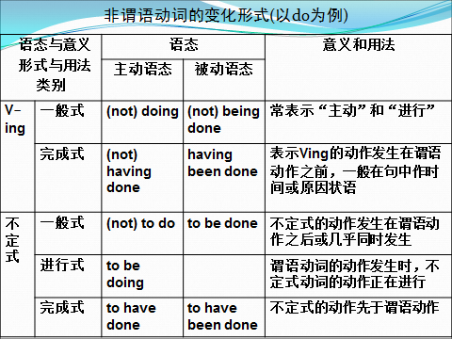
不定式用法
作表语 作定语 作状语 ： to…, only to (却……), in order to, so as to
e.g. He ran so fast as to catch the first bus.
他飞快地跑以便赶上第一班车。
*不定式为不及物动词时，须加介词
He is looking for a room _________(live). To live in
Please give me a knife ______________(cut). to cut with

I need a pen to write _______. 我需要一支笔写字。with（介词不能省略）
1.He bent down _________ (pick) the pen lying on the floor.（to pick）
2.He bent down and ________ (pick) the pen lying on the ground.（picked）
3.The teacher did what she could ______ me with my lessons. （D）
A. help B. helps C. helped D. to help
4. The doctor did everything he could _______ (save) the patient.(to save)
5. Every minute is made full use of ________ (study) our lessons.（to study）

动词不定式的时态和语态
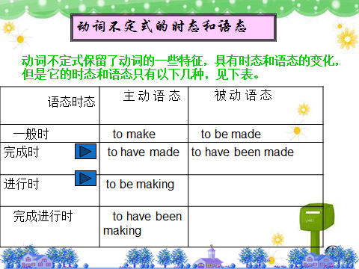
When I got home, my son happened to be watching TV.
如果不定式的动作发生在谓语动词之前，要用完成式。
She is said (to have read) thirty novels this year.
I'm sorry( to have kept )you waiting so long．
After graduation, he asked( to be sent) to work in the countryside.
This novel is said (to have been translated) into French.

动名词
动名词基本构成
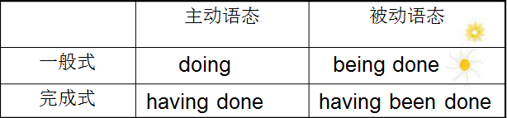
动名词性质
动名词既具有动词的特点有具有名词的特点，具体表现为：
1.动名词可以被定冠词和物主代词修饰
I hope you don’t mind my saying it.
2.可作动词宾语① S. + vt.+ doing
Have you finished reading the book?
I suggest doing it in a different way.
后只接动名词做宾语的一些常用特殊动词
特殊动词接“动名”，使用它们要记清，
避免错过 (少) 延期 avoid / miss /delay/postpone
建议完成 (多) 练习 suggest / advise/ finish /practise
喜欢想象 禁不住 enjoy/appreciate/ imagine/ resist / can’t help
承认 否定 (与) 嫉妒 admit / deny/envy
逃脱 冒险 (莫) 原谅 escape / envy /risk /pardon / excuse
忍受 保持 (不) 在意 stand / keep / keep on / mind掌握它们今必行。

1. 不定式与动名词无区别
start begin continue + to doing
[注意] 下列情况中begin和start后须接不定式
主语是物不是人 Spring came on, and the snow began to melt.
begin和start用于进行时态 It’s beginning to snow.
后接表示心理活动或状态的动词，如：understand, realize, know I began to realize how stupid I was.
后接不定式被动式 The new type of computer began to be developed in the 1980’s. 2. 不定式与动名词区别细微
love hate like prefer + to doing
后接动名词表示经常性的动作，多指一个人的爱好、习惯等，后接不定式表的某一次动作
I like ____swiming__ (swim) in summer.
I didn’t like _ to swim__ (swim) that day.
3.不定式与动名词区别很大 : remember forget regret try mean stop go on can’t help
a. I remember（visiting） his parents when I went to the town.
I’ll remember（to visit ）his parents when I go to the town.
b. He’s forgotten（switching）off the light.
He forgot（to switch ）off the light when he left.
c. I regret（aying） those words.
I regret（to say） that I can’t come tonight.
d. He tried（teaching） the children in a new way.
He tried（to teach ）the children as much as he could.
1. Boys, don't forget _____ the windows before you leave the classroom. D
A. closing B. closed C. to closing D. to close
2.She reached the top of the hill and stopped _______ on a big rock. C
A. to have rested B. resting C. to rest D. rest
3. Remember _______ the lights when you leave the office. A
A. to turn off B. turning off C. turn off D. to turning off

1.The teacher is coming, let’s stop _________ (talk). talking
2.He forgot ever ________ (write) to me, so he wrote another one. writing
3.I remember _______ (bring) the book to you last week. bringing
4.I regret ________ (tell) that we can’t take your advice. to tell
5. Revolution means ____________(liberate) the productive forces. liberating
6. Go on ________ (do) the other exercise after you have finished this one. to do

分词的否定式
- 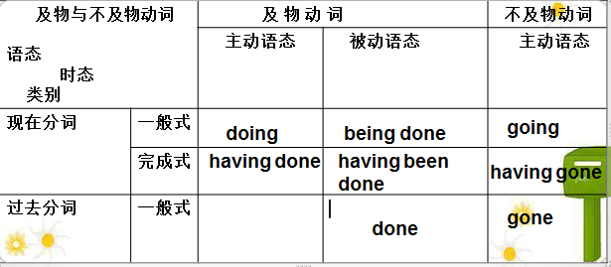
not + 分词
- Not having received his letter, he decided to call him.
- Not knowing his address, she cannot get in touch with him.
现在分词表主动进行，过去分词表被动完成
- 1.(Seeing/seen) from the top of the tower, we can see a beautiful factory.
- 2. (Seeing/seen) from the top of the tower, the factory looks beautiful.
- 3. (Hearing/heard) the bad news, they couldn’t help crying.
- 4. (Giving/Given) more time, we could do it better.
- 5.I stood by the door, not daring to say a word.
非谓语动词作定语
- ①过去分词作定语与其修饰词之间是动宾关系且过去分词表示的动作已完成。相当于一个被动语态的定语从句。
- ② 现在分词作定语表示动作正在发生，与修饰词是主谓关系。
- ③不定式作定语表示将要发生的动作。
分词作插入语
- 其结构是固定的，意思上的主语并不是句子的主语。
generally speaking 一般说来
talking of (speaking of) 说到
strictly speaking 严格的说
judging from 从…判断
all things considered 从整体来看
taking all things into consideration 全面看来
- Generally speaking, dogs can run faster than pigs. 总的来说，狗比猪跑得快。 (speaking 并不是dogs 的动作)
- 练习
- European football is played in 80 countries, ___ it the most popular sport in the world.
- A. making B. makes C. made D. to make
- 选A，现在分词短语作结果状语，这类分词短语常放在句子的后面, ing表示顺其自然，不定式表示突然，出乎意料。、
- e.g. His parents died, （leaving ）him an orphan.
- He rushed to the post office only （to find ）it was closed
- 练习
- The managers discussed the plan that they would like to see ______ the next year.
- A. carry out B. carrying out
- C. carried out D. to carry out
- 选C。该题考查过去分词作补语的用法。The plan 与carry out 的关系是被动关系。see sth. done 这结构常见的还有watch (notice, observe, have 和 make) sth. done.
分词作宾语补足语，通常在感官动词和使役动词之后，要看分词与宾语的关系：
若为主动关系，则用现在分词；若为被动关系，则用过去分词。
e.g. make sb. heard / understood
(使别人能听见/理解自己)
- 练习
- The patient was warned ____ oily food after the operation.
- to eat not B. eating not
- C. not to eat D. not eat
选C。该题考查不定式的否定式作主补。要注意warn后跟词方式， ① warn sb. not to do sth. ②warn sb. against doing sth. 该题应该用①结构，且not应放在to之前。
- 练习
- The Olympic Games,___ in 776 B.C. did not include women players until 1912.
- A. first played B. to be first played
- C. first playing D. to be first playing
- 选A。注：first played in 776 B.C.=which was first played in 776 B.C.
- 练习
- I found my car ________. 我发现我的车不见了。missing
- I'll have my watch ________. 我想把我的手表修一下。repaired
- He had his leg _______ in the basketball match yesterday. 他的腿在昨天的篮球比赛中受了伤。Injured
修改句子—分词作状语
- Walking through the park, the flowers looked very beautiful. (wrong) Walking through the park, we saw a lot of flowers.
- Standing on the tower, the whole village could be seen. (wrong) Standing on the tower, we could see the whole village.
独立主格结构
- 1）独立主格结构的逻辑主语与句子的主语不同，它独立存在。
2）名词或代词与后面的分词、形容词、副词、不定式、介词等是主谓关系。
3）独立主格结构一般有逗号与主句分开。
- e.g.Weather permitting, we are going to visit you tomorrow. 如果天气允许，我们明天去看你。＝ If weather permits, we'll go out for a walk.
2011年 All flights ____ because of the snowstorm, many passengers could do nothing but stay at the airport. D
A. had been cancelled B. were cancelled
C. having been cancelled D. have been cancelled
With的复合结构作独立主格
- with +名词(代词)+现在分词/过去分词/形容词/副词/不定式/介词短语: 表伴随。
典型例题The murderer was brought in, with his hands ___ behind his back。
A. being tied B. having tied
C. to be tied D. tied
答案D. with +名词（代词）+分词+介词短语结构。当分词表示伴随状况时，其主语常常用with来引导。由于本句中名词“手”与分词“绑”是被动关系，因此用过去分词，选D。
定语从句只用that的情况
- 先行词为不定代词everything，little，much，all，anything，nothing。
- e.g. Finally, the thief handed everything that he had stolen.
- 先行词前有形容词最高级、序数词修饰时，用that。
- e.g. This is the best book (that) I’ve ever read
- 先行词被the only，the very，the last 修饰时，用that。
- e.g. He is the only person that I want to see now.
- “介词+关系代词”的用法
- 可用来限定名词、代词、分数词、数词等。
e.g. 1. In the dark street, there wasn’t a single person ____________ she could turn for help.
- A. that B. who C. from whom D. to whom
2. He paid the boy $10 for washing the windows, most of ________ hadn’t been cleaned for at least a year.
- A. these B. those C. that D. which
as/which 引导非限定性定语从句
(1) 位置不同：as 具有正如之意，引导的非限制性定语从句位置随你意，可在句前、句中、句后；which引导的非限制性定语从句不能用于句首。
As we had expected, the meeting was canceled.
The meeting, as we had expected, was canceled.
The meeting was canceled, as we had expected.
(2)如从句中行为动词是主动语态，一般要用which作主语。
- Tom has made great progress, which made us happy.
- (3)与such或the same连用时，一般用as.
- Such books as you tell me are interesting.
as anybody can see 正如人人都能看到的那样
as we had expected 正如我们所预料的那样
as is known to all 众所周知
as is often the case 正如经常发生的那样
as is mentioned above 正如上面提到的
as has been said before 如上所述
- 定语从句中：
若先行词是one of+名词复数,定从谓语用复数；若先行词是the only one of+名词复数,定从谓语用单数
Tom is one of the students who were praised by the teacher yesterday.
Tom is the only one of the students who was praised by the teacher yesterday.
*Is this factory ___ we visited last week? D
A. where B. that C. which D. the one
*This factory is ___ we visited last week.
A. where B. that C. which D. the one
口诀
先行词没有，the one/ones加前头
Is this problem the one you have thought of for ten years?

主语从句
- ★主语从句一律用陈述句语序,即主语在前,谓语在后. 连接词that在从句中无实际意义,但不能省略. ★whether可以引导主语从句, 但if不能.
- ★ whoever, whatever, whichever等词可以引导主语从句, 但no matter who, no matter what 不能.
- e.g. 1.That he is a famous singer is known to us.
- (It is known to us that he is a famous singer.)
- e.g. 2.When he will go to America is not yet fixed.
- (It is not yet fixed when he will go to America.)
表语从句
- 不要使用 The reason … is because that … 句型, 应使用 The reason… is that… 或 This/ it/ that is because…等句型.
- 例如: 今天早上他迟到的原因是因为路上行人太多.
- 误: The reason why he was late this morning is because that there was a lot of traffic on the road.
- 正: The reason why he was late this morning is that there was a lot of traffic on the road.
- 或:He was late this morning. That was because there was a lot of traffic on the road.
只能用whether
- whether与if均为“是否”，但下列情况下只用whether ：
- 1. whether引导主语从句并在句首
Whether he will come is not clear.
- 2. whether引导表语从句
- The question is whether he’ll come.
- 3. whether从句作介词宾语
- I’m not sure about whether we’ll win.
- 4. 从句后紧跟“or not”或 “to…”
Whether you like it or not, you’ll have to do it.
虚拟语气】
Be型：即谓语动词用do或should do
1）想要(desire)、宁愿(prefer)、命令(order, command)、建议(advise, suggest, propose, recommend, urge)、要求(demand, require, request, ask, insist, maintain)中，从句的谓语动词用(should) do。
e.g. He suggested that we (should) take the teacher’s advice.
2) 表情绪、观点的形容词或名词也要用虚拟语气。如：necessary, important, urgent, impossible, essential, desirable, proper, recommendable, advisable, natural, strange, surprising, a pity 等。
句型：It is … that + (should) do
3) 凡是由lest (以免, 免得), in case (以防), for fear that (生怕, 唯恐)引导的状语从句中，用(should) do。
e.g. Keep quiet in case you (should) interrupt him when he is busy.
Were型：即谓语动词用过去式
1）It is (high, about) time (that) + did
该……的时候了
2) wish/ as if/ as though/ if only/ would rather/ would sooner + 从句时，有三种情况，各自把时态推到过去。现在用did (be用were)，过去用had done，将来用过去将来时would do (be用were)
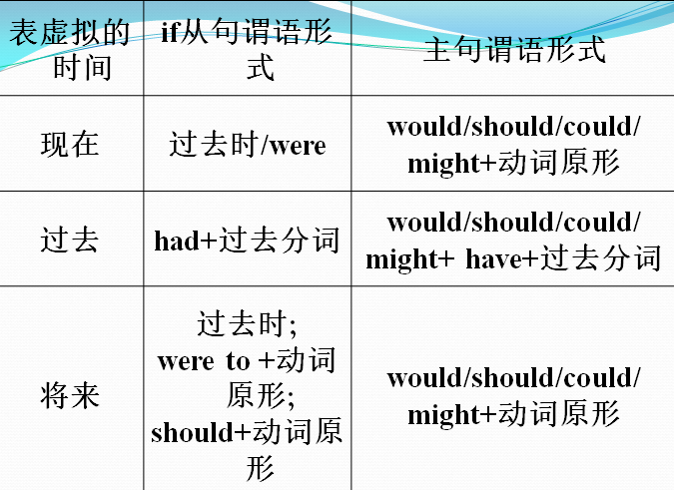
- 记住固定结构，除非能在时间状语中找到混合时间的证据，否则都按照固定结构搭配。
- e.g. If you had worked hard, you would have passed the examination.
- e.g. If you had worked hard, you would pass the examination tomorrow.
- 注意：
- 当从句中含有had, should, were, 可以省掉if，改为倒装形式。
If only + V-ed
- 结构︰If only＋过去式／过去完成式
- 说明︰此句型意为“要是…就好了”。
- 1) 用过去式，表示与现在事实相反；
- 2) 用过去完成式，表示与过去事实相反。
If only I had a rich father. 要是我有个有钱的爸爸就好了。
区别：only if(只要)是if的强调形式

If I should ..., I would...
- 结构：If…should…，…would／should ＋ do
- 表示与未来事实相反的假设，可译成“万一”。
- If he should come, I would tell him the truth. 万一他来，我会把真相告诉他。
- If it should rain, our plan would be spoiled. 万一下雨，我们的计划就泡汤了。
If I were to ..., I ...
- 结构：If…were to…，…would/should + do
- 这也表示与未来状况相反的假设，与“if ... should, ...”大致相同，但“if ... were to”所表示的可能性更低，通常用以表示“与真理相反”的假设语气。
- e.g. If the sun were to rise in the west, he would pass the exam.
would rather/sooner
- would rather/sooner do...than do：“宁愿…也不”
- He would rather resign than take part in such dishonest business deals.
would rather+从句：
1) 现在/将来的动作：谓语用过去时。
2) 过去的动作：谓语用过去完成时。
- John wants to see me today. I would rather he came tomorrow than today.
约翰今天想去看我。我宁愿他明天来看我而不是今天。(句中came不是表示过去而是表示将来)
“要不是”
- Were it not for his help, I could not finish the work. (If it were not for…)
- 若非有他的帮助，我就不能完成这件工作。
- Had it not been for the kind guide, I might have got lost in the mountains. (表示与过去事实相反的假设语气)
- 要不是这位好心的向导, 我可能就在山中迷路了。
- But for your advice, I should have failed.
- 要不是你的忠告，我会失败的。
倒装
- 1) 否定词或半否定词位于句首
- e.g. Little did he care about his relatives.
- 2) only + 状语位于句首
- 3) neither / so 位于句首
- 4) 某些副词开头的句子构成的完全倒装here, there, now, then, thus等副词开头的句子可构成完全倒装。条件是谓语动词是不及物动词，如arise, be, come, exist, go, follow等。注意，当主语是代词时，不能倒装
- 5) 充当表语的地点状语位于句首
2011. _______ man realized that the brain controlled our thinking. A
A. It was not until the 18th century that B. It was the 18th century since
C. Not until the 18th century did D. It was until the 18th century which
倍数表示法
- 1) A+ Be +倍数(或分数)+ as + adj. + as B
- The cat is three times as big as the mouse.
- 2) A+ Be +倍数(或分数) + the size (amount, length…) of B
- The cat is three times the size of the mouse.
- 3) A+ Be +倍数(或分数)+ adj.比较级 + than B
- He is a head taller than me.
- 4) 还可以用by+倍数，表示增加多少倍
- The production of grain has been increased by four times this year.
- 今年粮食产量增加了4倍。
必胜考点
- There is no +名词+（in）+ doing ……是没有……的
- 名词主要有：use, good, sense, point等。
- e.g. There is no good (in) making friends with him. 和他交朋友是没有好处的。

it作形式主语使用动名词的句型
- ① It is no use/no good/useless + doing sth.
- 哭没有用。
- It is no use crying.
- ②It is fun (a great pleasure, a waste of time) + doing sth.
- 设法解释是浪费时间。
- It is a waste of time trying to explain.
anything/ nothing/ all but
- “anything but”=never, “nothing but”=only, “all but”=almost, nearly。
- He is anything but a scientist.他绝不是科学家。
- I am nothing but a student.我只不过是个学生。
- He is all but a fool.他几乎是个傻瓜。
“superior to”、“inferior to”、“senior to” 和“junior to”
- “superior to”：优于，高于；
- “inferior to”：次于；
- “senior to ”：年长于，地位高于；
- “junior to”：年幼于，地位低于，迟于。
介词to + doing
- admit to
- confess to
- be accustomed to
- be used to
- stick to
- devote oneself to
- be devoted to
- look forward to
- pay attention to
多个形容词修饰名词
其语序为：
限定词--数词--描绘词--(大小，长短，形状，新旧，颜色) --出处--材料性质，类别--名词
县(限定词The, A)+数(数词)+官(外观和感官形容词, pretty, small)+行(形状, round)+令(年龄, 时间)+舍 “色”(颜色)+国(国籍, 来源)+财(材料)+purpose(目的, 用途)+名词
e.g. a small round table
- a dirty old brown shirt
- a famous German medical school
- a heavy black Chinese steel umbrella
练习One day they crossed the ____bridge behind the palace.
A. old Chinese stone B. Chinese old stone
C. old stone Chinese D. Chinese stone old
答案A. 几个形容词修饰一个名词，他们的排列顺序是：年龄，形状，大小+颜色+来源+质地+用途+国家+名词。

